Fall Semester 2025-26
Lab Assignment – 2
Slot: L13+L14
Class: VL2025260105679
Branch: B.tech CSBS
Course code & title: CBS3005
Cloud, Microservices and Applications
Faculty name: Nithya K
DA by:
Kartikey Gupta
22BBS0105

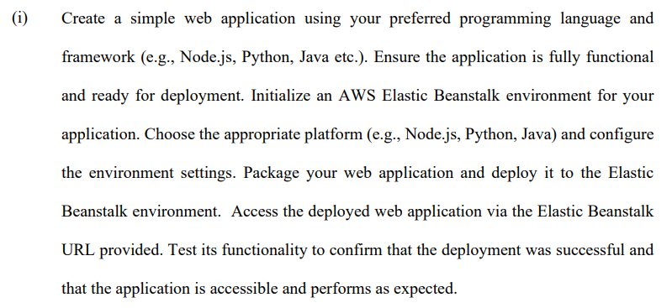
Step 1: Create a Simple Spring Boot Application
- Open in your IDE IntelliJ, or VS Code.
- Create new springboot project
  - Project: Maven
  - Language: Java
  - Spring Boot: latest stable version
  - Dependencies: Spring Web
- Group: com.cloud, Artifact: LA2
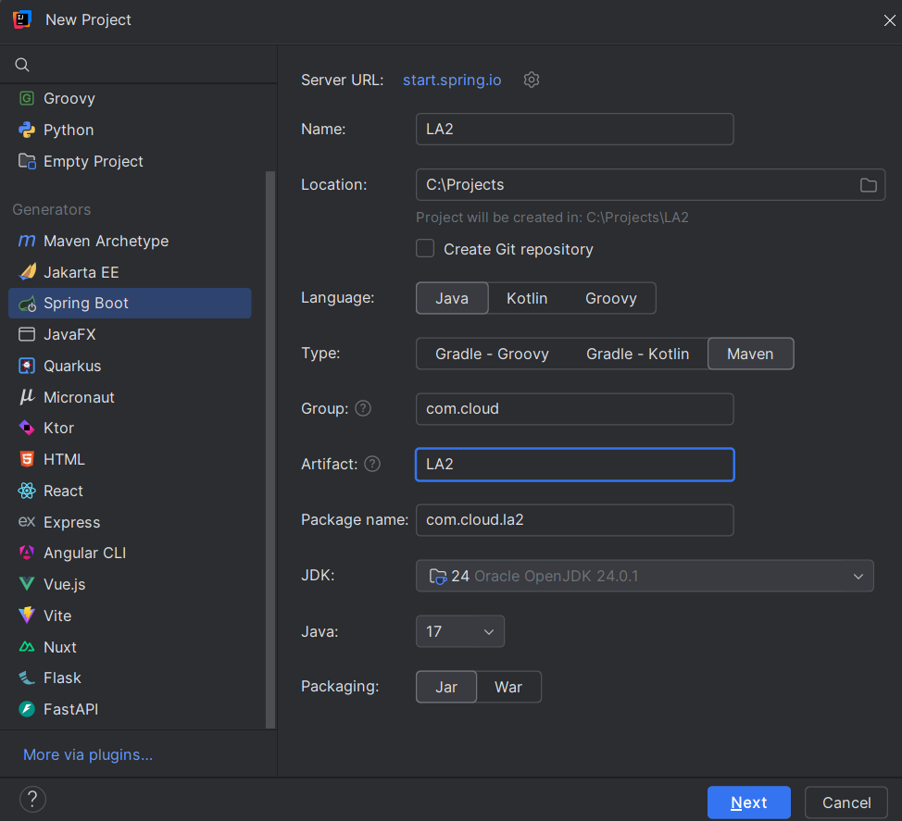
- Edit src/main/java/com/cloud/la2/La2Application.java to create a simple REST endpoint:
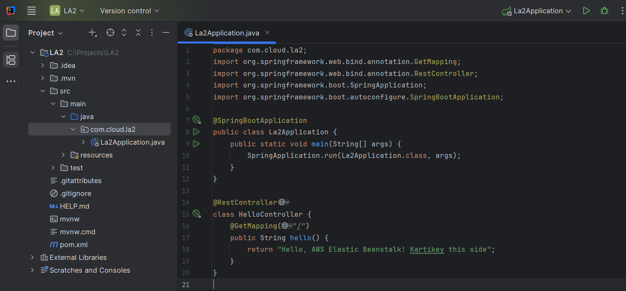
- Clean the project using mvn clean package
- Build success and Jar file created
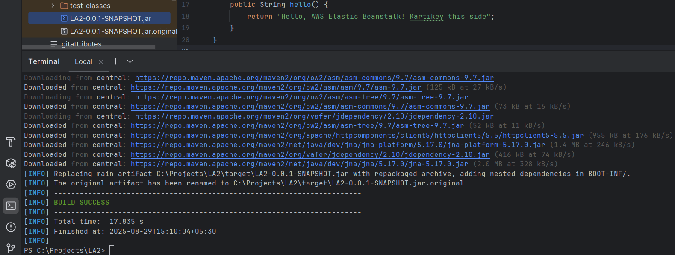
Step 2: Log in to AWS Management Console
- Go to AWS Console.
- Log in with your AWS account.
- Navigate to Elastic Beanstalk
Step 3: Create a New Application
- Click Create application.
- Enter Application name: La2JavaApp.
- Add an optional description: Sample Spring Boot app.
- Click Create application
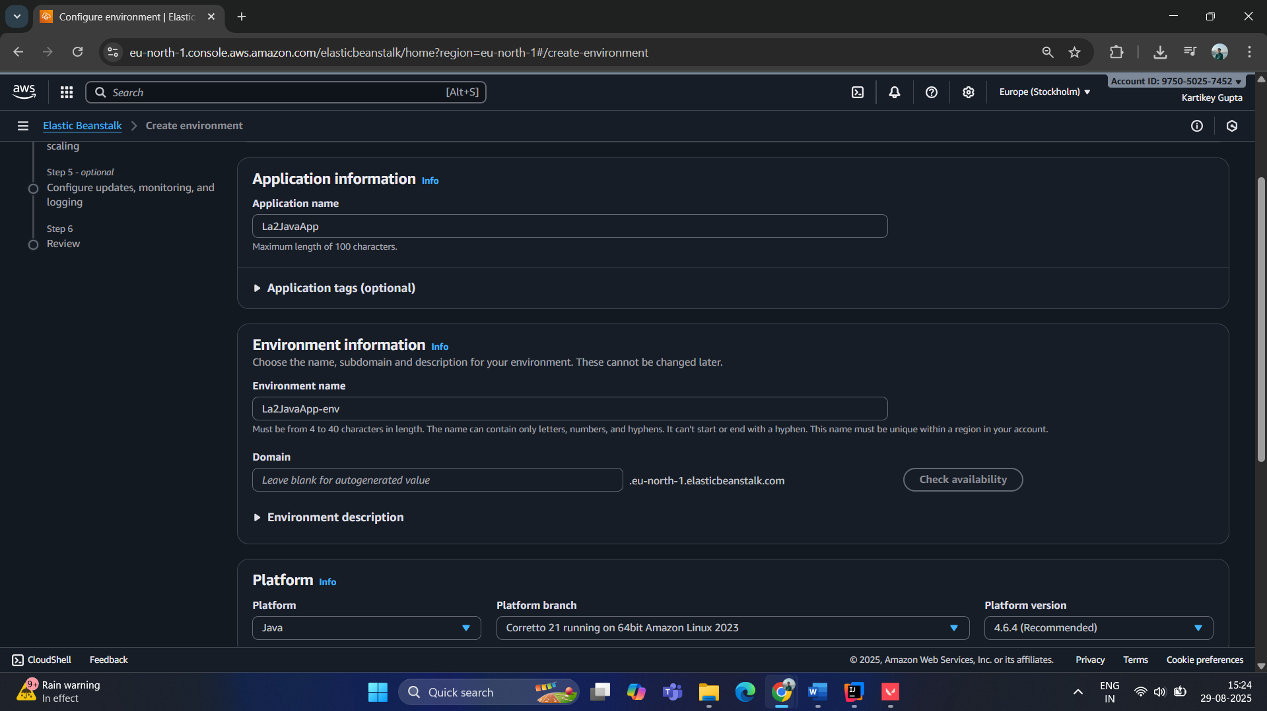
Step 5: Configure Environment and Platform
- Environment name: La2JavaApp-env
- Platform: Choose Java
  - For Spring Boot JAR: choose Corretto 17 (or latest Java 17+)
- Platform branch: Keep the default
Step 6: Upload Your Application
- Under Application code, choose Upload your code.
- Click Choose file and select your JAR file from target/.
Step 7: Optional Environment Settings
- Instance type: For testing, choose t2.micro (free tier eligible).
- Capacity: Keep single instance.
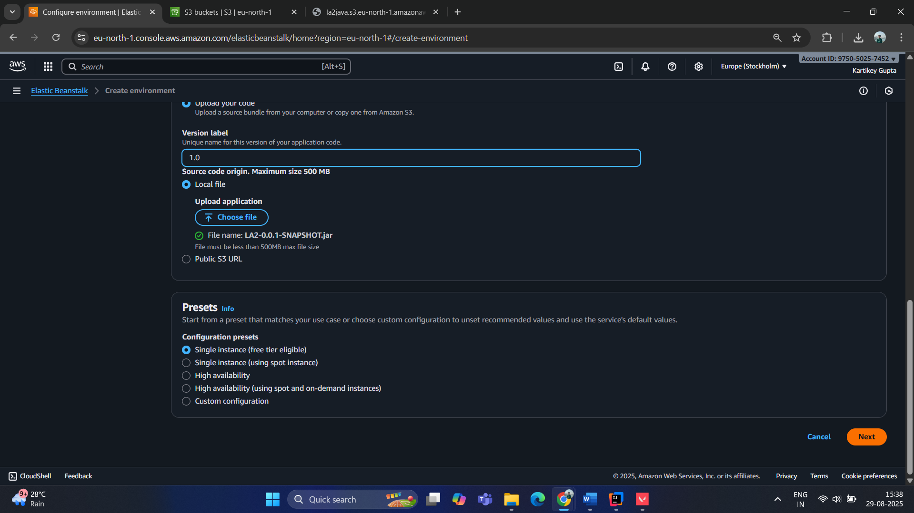

Uploading JAR file:
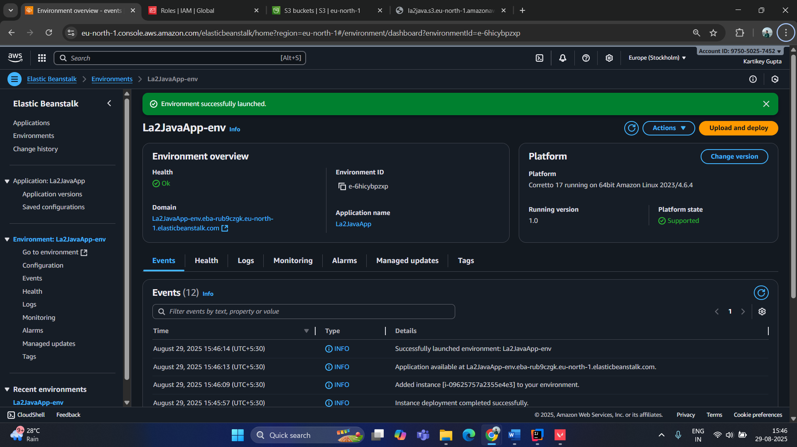
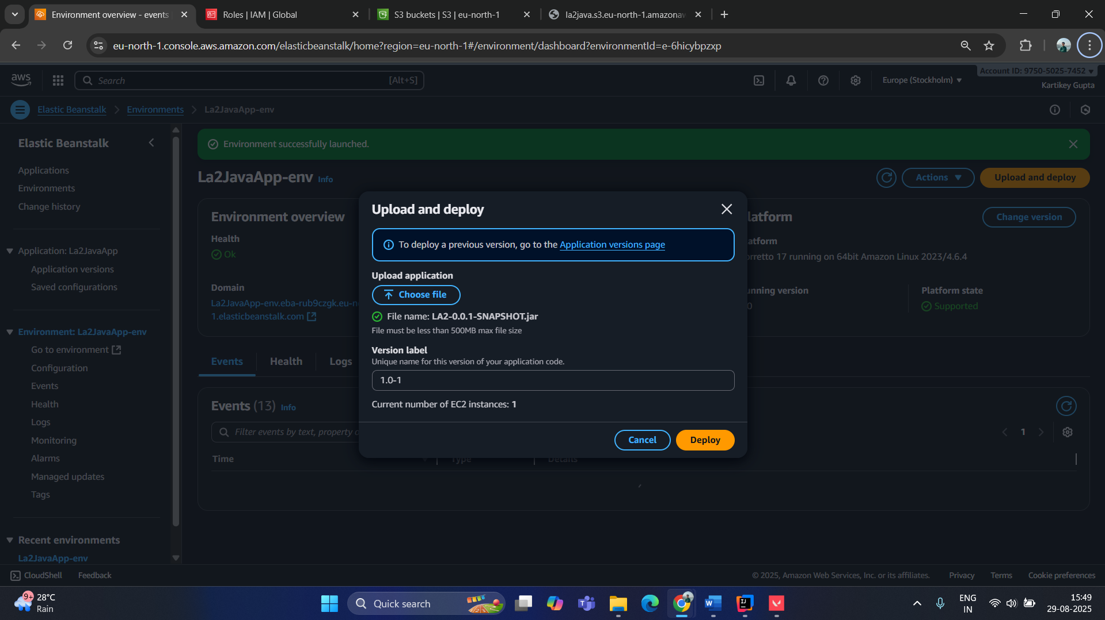
Environment created successfully
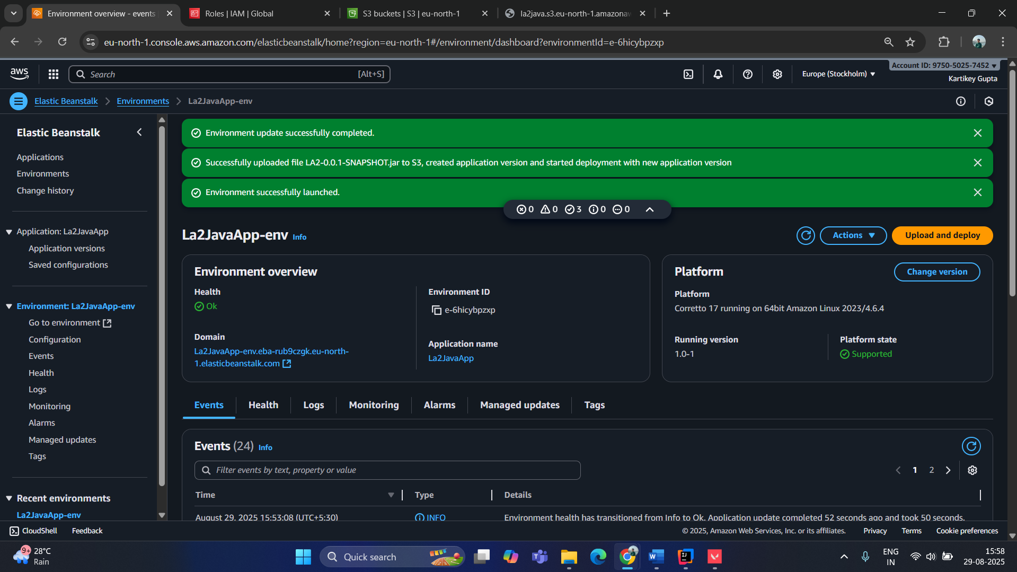
Accessing using the link: (will disable later due to incurring charges)
http://la2javaapp-env.eba-rub9czgk.eu-north-1.elasticbeanstalk.com/
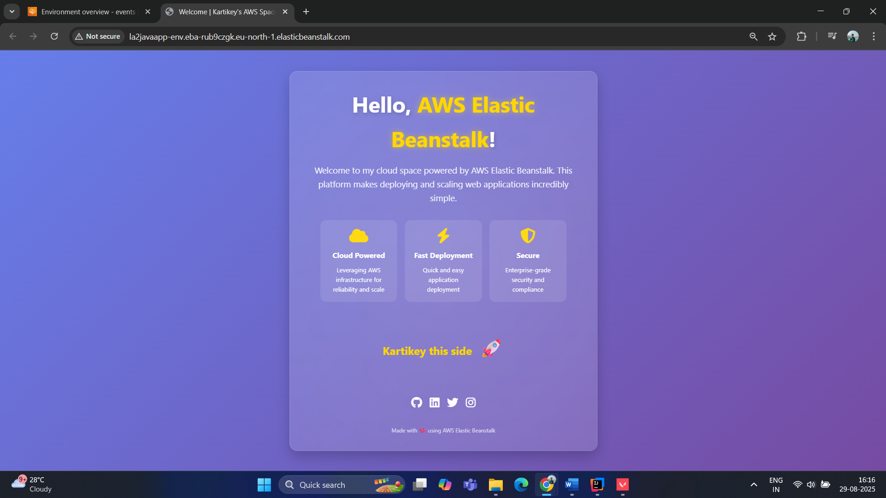

Deployed web application successfully via the AWS Elastic Beanstalk!!

